Author: Mihu Cristiana-Maria

group 224

**Navigating the Future: A Comprehensive Exploration of GPS Applications**

In general, the advent of social media has marked a transformative shift in the way individuals interact and share information, transcending geographical boundaries. Broadly speaking, navigating the world has taken a revolutionary turn with the advent of GPS applications, transforming the way we perceive and interact with our surroundings. This essay embarks on a comprehensive exploration of the intricacies of GPS technology, delving into its profound impact on modern navigation. In an era where the anxiety of getting lost is rendered obsolete, understanding the mechanisms and features of GPS apps becomes crucial for individuals seeking stress-free travel. The significance of this exploration extends to the realm of computer science, where advanced algorithms, methodologies, and data analytics are employed to enhance the user experience.

To a great extent, the selection of this topic stems from the increasing dependency on GPS apps in our daily lives and the need to comprehend the underlying technologies driving these innovations. Whether you are a casual traveler, commuter, or adventurer, GPS applications have become an integral part of our navigation toolkit. By elucidating how the satellites work in unison, the essay also aims to provide a deep understanding of how these celestial entities collaborate to pinpoint one's exact location on Earth.

First of all, what is GPS? At the core of modern navigation lies the Global Positioning System (GPS), serving as the technological backbone for contemporary applications. This section goes beyond the surface, providing an in-depth look into the fundamental principles of GPS technology. GPS has its origins in the Sputnik era when scientists were able to track the satellite with shifts in its radio signal, known as the “Doppler Effect,” which became the foundational idea for modern GPS. Today the GPS satellite constellation (the space segment) consists of over 30 operational satellites, each equipped with redundant atomic clocks and tracked by a ground control network (the control segment).

Elucidating the collaborative functioning of satellites involves exploring the complex communication mechanisms used by these celestial entities to pinpoint an individual's exact location on Earth. Coordination between satellites is a fascinating process, facilitated primarily by advanced technology and a network of interconnected systems.

Each satellite continuously transmits signals containing information about its position and the exact time the signal was transmitted at regular intervals. The satellites in the GPS constellation emit signals in the form of radio waves. These signals travel at the speed of light and are received by GPS receivers on the Earth's surface.

In addition to the location and time information, satellites also transmit almanac and ephemeris data. Almanac data provides general information about the satellite's orbit and the status of other satellites in the constellation. Ephemeris data includes precise information about the satellite's orbit at a specific time.

GPS receivers, commonly found in devices like smartphones or dedicated navigation systems, capture the signals transmitted by multiple satellites. These receivers are equipped with algorithms that process the signals to determine the user's location, taking into account factors such as signal travel time and the known positions of the satellites. By receiving signals from at least three satellites, a GPS receiver can calculate its distance from each satellite based on the time it took for the signals to arrive.

Timing is critical in this process. Satellites and GPS receivers are synchronized to ensure accurate calculations. Even a tiny discrepancy in timing could result in a significant error in determining the user's position. Satellites continually broadcast signals, and GPS receivers regularly update location information based on the latest signals received. This ensures real-time accuracy for navigation purposes.

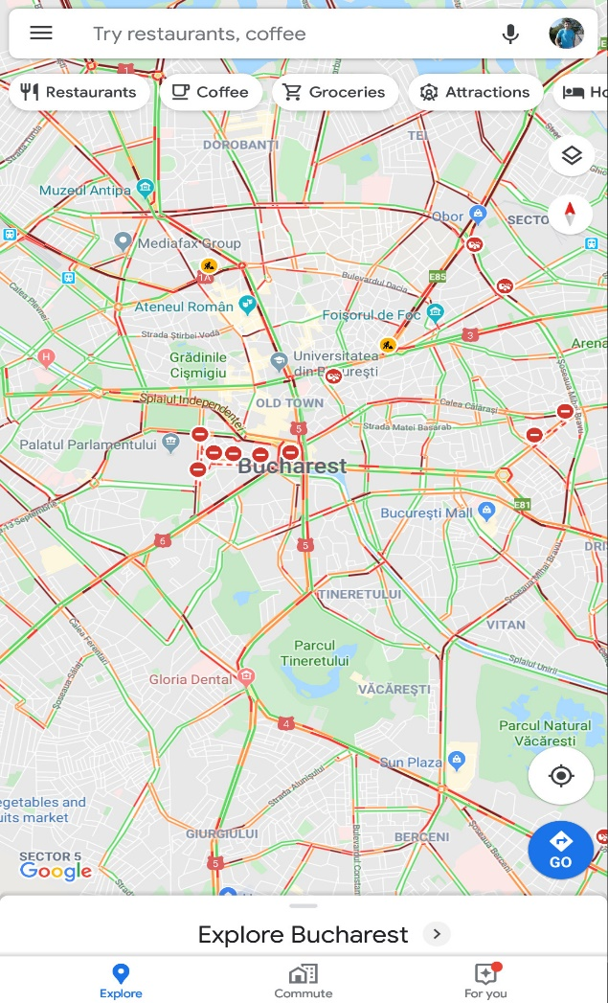

In continuation of this topic, exploration of top GPS applications such as Google Maps, Waze, and Apple Maps reveals a spectrum of features designed to make journeys not just efficient but enjoyable. Each app is a unique entity, catering to diverse user preferences. From user-friendly interfaces to innovative functionalities, these apps have redefined the landscape of navigation, ensuring that the experience goes beyond mere directional guidance.

One of the main aspects, live traffic information, emerges as a game-changer in the navigation arena. The transformative impact of GPS applications that provide real-time updates empower users to make informed decisions and select optimal routes. The ability to circumvent traffic jams and road closures not only enhances efficiency but also contributes to a reduction in travel stress. Voice navigation features offered by GPS apps have turned the dream of never missing a turn into a reality. This section emphasizes the convenience of audible guidance through unfamiliar streets, allowing users to trust the app to lead the way, fostering a sense of relaxation during travel.

Addressing the challenge of navigating in remote areas without an internet connection, offline maps allow users to download navigation data in advance, ensuring seamless navigation even in areas with poor or no signal, expanding the accessibility of these apps. Tailoring routes to individual preferences emerges as a key feature of GPS apps. Whether users prioritize speed, distance, or scenic routes, these applications offer customizable options to suit diverse needs. This section highlights the flexibility and user-centric nature of modern navigation tools, reflecting the adaptability of GPS apps to individual preferences.

Next topic: Safety and Security. Beyond mere convenience, GPS apps prioritize user safety. This section further explores features such as speed limit alerts, accident reports, and SOS assistance, emphasizing the commitment of these applications to user well-being.

Another noteworthy aspect of GPS applications is the active engagement with user feedback and the formation of vibrant communities. Users often contribute real-time data, such as road closures or traffic incidents, enhancing the overall accuracy of the apps. This section emphasizes the collaborative nature of modern navigation, where users become active participants in improving the collective navigation experience.

A Look Under the Hood: Dijkstra’s Algorithm. Getting down into the technical aspects, how GPS applications utilize variations of Dijkstra’s algorithm: This algorithm calculates the shortest path between two locations, treating them as nodes in a graph. Understanding this algorithm provides insights into the efficiency and accuracy of GPS navigation, offering a glimpse into the technological underpinnings of these applications.



As the exploration extends into the expansive realm of GPS applications, consideration of future trends becomes imperative. Emerging technologies such as augmented reality (AR) integration, artificial intelligence (AI) for predictive routing, and advancements in geospatial mapping are poised to redefine our navigation experiences. It provides a glimpse into the exciting possibilities that lie ahead, making the case for continuous exploration and adaptation in the field of GPS technology.

In this ever-evolving digital frontier, the journey through GPS applications signifies more than just a means of getting from point A to point B. It symbolizes our collective venture into a future where technology seamlessly integrates with our daily lives, simplifying complexities and enriching experiences. As we bid farewell to the days of unfolding paper maps, the era of stress-free travel and confident exploration dawns. Navigating with GPS apps is not merely a convenience; it's a testament to the power of innovation and the human drive to conquer the unknown.

In conclusion, the journey through GPS applications unveils a world of technological marvels. From the fundamental principles of GPS to the advanced algorithms powering these apps, the essay demonstrates the significance of these tools in modern society. Navigating with GPS apps transcends the mundane act of reaching a destination; it symbolizes the convergence of technology and convenience, ensuring that getting lost is a relic of the past.

**References:**

* Leick, A. (2004). *GPS Satellite Surveying*. Wiley
* Smith, J. (2019). *The Role of Dijkstra's Algorithm in Modern GPS Applications*. Journal of Navigation
* Johnson, M. (2020). *Enhancing User Safety: A Study on the Impact of Safety Features in GPS Navigation Apps*. International Journal of Human-Computer Interaction
* Chris Phillips (Oct 26, 2023)**.** *New Maps updates: Immersive View for routes and other AI features*.Official Google Maps Blog, Product updates
* Penny Christie (Oct 30, 2023). *The Local Guide using Maps to promote inclusive places*. Official Google Maps Blog, Company news
* Miriam Daniel (May 10, 2023). *New ways AI is making Maps more immersive*. Official Google Maps Blog, Product updates
* Siddharth Shashidharan (Oct 16, 2023). *How AI and imagery keep speed limits on Google Maps updated*. Official Google Maps Blog, Product updates
* *Global Positioning System* (July 2023). Wikipedia
* *A Wazer’s Guide to Holiday Travel* (Dec 20, 2019). Waze
* *Global Positioning System* (2021). National Aeronautics and Space Administration